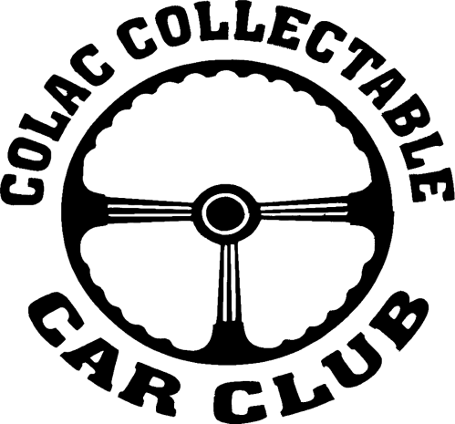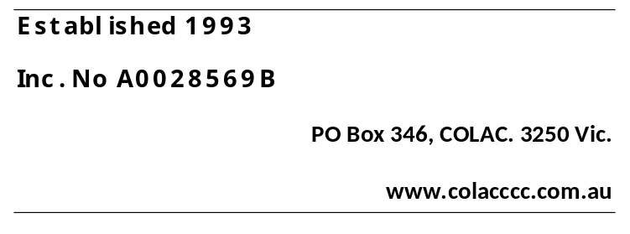

APPLICATION FOR MEMBERSHIP
COLAC COLLECTABLE CAR CLUB INC.

NAME:- ____________________________________________

ADDRESS:- ___________________________________________Post Code:-

PHONE:- (Home) ______________________ (Mobile) _____________________

EMAIL:- ________________________________________
(Please supply email address to receive Newsletters and reminders etc. )

To apply for membership, you need to have a current Club Member nominate you and another Club Member to second your application.

Nominated by | Name: | Signature
Nominated by | Address:
Seconded by | Name | Signature
Seconded by | Address:

Please list your Collectable vehicle or motorcycle :-

Year | Make | Model | Body Type | Registration No. | Registration Expiry Date

Please note:-

I understand that to be an active member of the Colac Collectable Car Club (once Covid-19 restrictions ease), I must attend 5 club activities in the first 12 months before I can place a vehicle on Vic Roads Club Permit Scheme.
The club will be in contact with you once your membership application has been discussed at a Committee Meeting. A $50 Membership joining fee is due after acceptance of your application;
Inspection fee if required:- $25 if inspector comes to you to inspect your vehicle – no fee if you take your vehicle to an inspector;

I agree to the above terms of membership and understand my membership application will be placed on the Colac Collectable Car Club’s waiting list until a vacancy becomes available:-

APPLICANT SIGNATURE:- ____________________________Date:

___________________________________________________________________________

