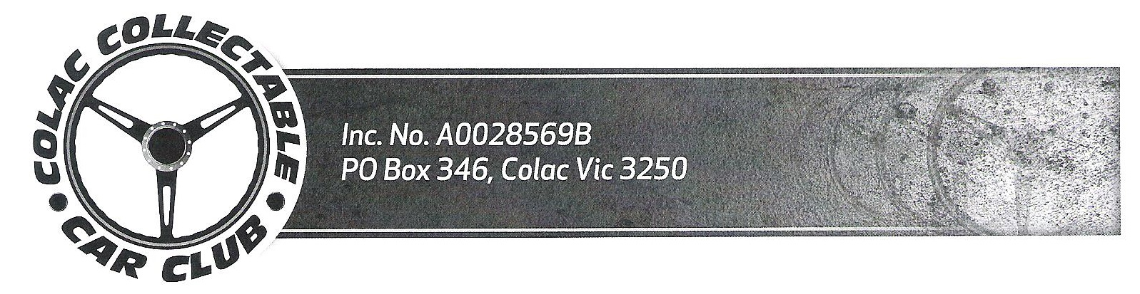
APPLICATION FOR MEMBERSHIP
COLAC COLLECTABLE CAR CLUB INC.

NAME:- ____________________________________________

ADDRESS:- ___________________________________________Post Code:-

PHONE:- (Home) ______________________ (Mobile) _____________________

EMAIL:- ________________________________________
(Please supply email address to receive Newsletters and reminders etc. )

To apply for membership you need to have a current Club Member nominate you and another Club Member to second your application.

Nominated by | Name: | Signature
Nominated by | Address:
Seconded by | Name | Signature
Seconded by | Address:

Please list your Collectable vehicle or vehicles:-

Year | Make | Model | Body Type | Registration No. | Registration Expiry Date

PLEASE NOTE:-
- Joining Membership is $50 per year due upon acceptance of your application;
- Inspection fee if required:- $25 if inspector comes to you to inspect vehicle – no fee if you take vehicle to inspector;
- All members are required to attend at least two General Meetings and two club events per year to remain eligible for renewal of membership for the following year.

I agree to the above terms of membership:-

APPLICANT SIGNATURE:- ____________________________Date:

___________________________________________________________________________
OFFICE USE ONLY:
Received: ……………….Date Paid:- …………..Receipt No:- ………… Membership No:- ……………

